**CameraCube**

**Image Transfer**

Rev 0

**Table of Contents**

1 Overview 3

2 Software Requirements 3

3 Demonstration Design 3

4 Revision History 8

# Overview

Project “CameraCube Image Transfer” demonstrates the capability of the MTX-BC48-DB board.

# Software Requirements

Necessary install the following software before to implement a project designs on the MTX-BC48-DB board:

* Lattice Radiant Software from the <http://www.latticesemi.com/Products/DesignSoftwareAndIP/FPGAandLDS/Radiant>

# Demonstration Design

Project “CameraCube Image Transfer” files located in the CameraCube_Image_Transfer.zip file. The CameraCube_Image_Transfer.zip located in <https://github.com/mitexus/MTX-BC48-DB-Development-Board/tree/Documents/projects/Image%20Transfer> .

To run the project demonstration:

1. Unzip CameraCube_Image_Transfer.zip (Figure 1)

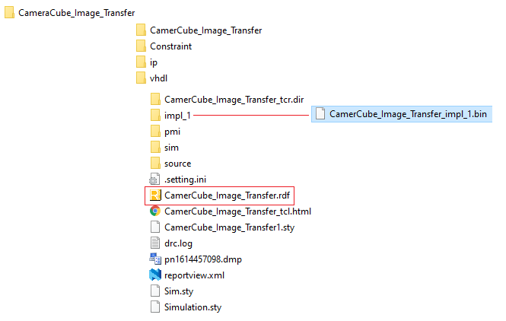

**Figure 1. Unzipped project files**

1. Double click to CamerCube_Image_Transfer.rdf . Lattice Radiant software is opening (Figure 2).
2. Click on Programmer icon shown inside red square on Figure 2. The Radiant Programmer is opening (Figure 3). Make sure the proper items selected as shown on Figure 3.
3. Connect the MTX-BC48-DB board via the USB cable to a PC.

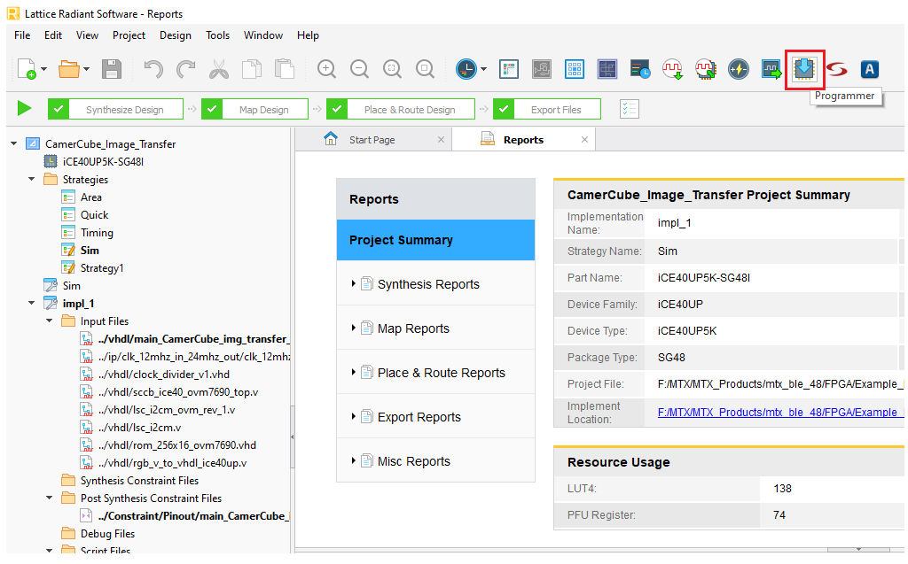

**Figure 2. Project view**

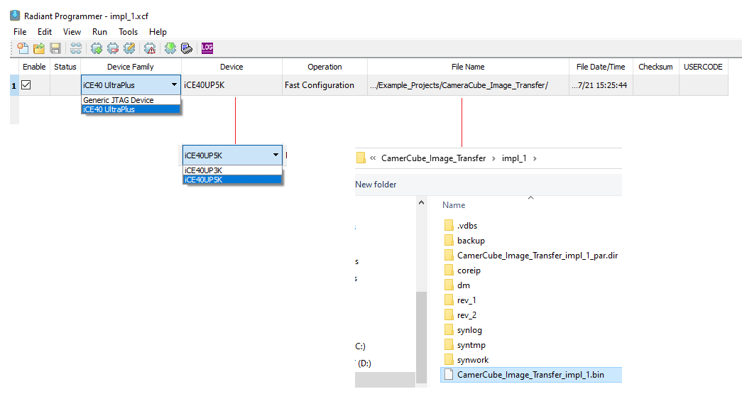

**Figure 2. Programmer view**

1. Select programmer cable (Figure 3):
   1. Click on “Detect Cable” button on Cable Setup menu.
   2. Click on OK button
   3. Cable detection results appearing on the output window.

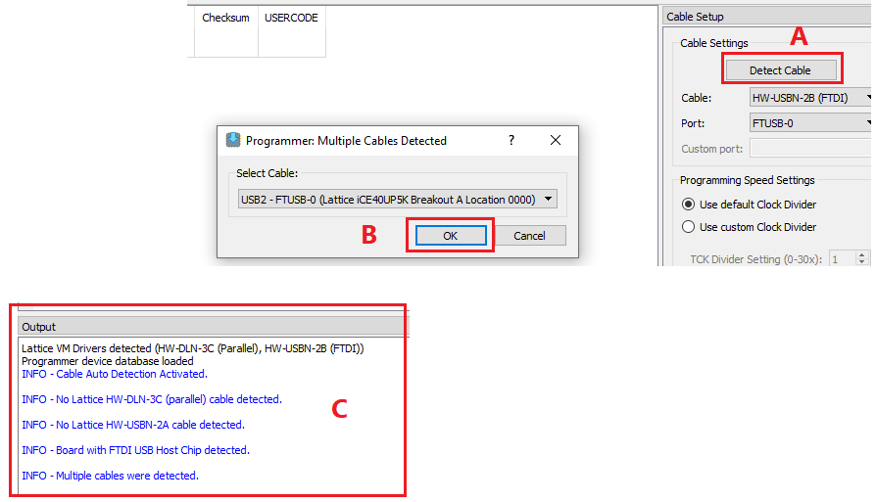

**Figure 3. Programming cable detection**

1. Programming of the FPGA (Figure 4):
   1. Click on “Program Device” button.
   2. Programming is continuing.
   3. Programming finished successfully.

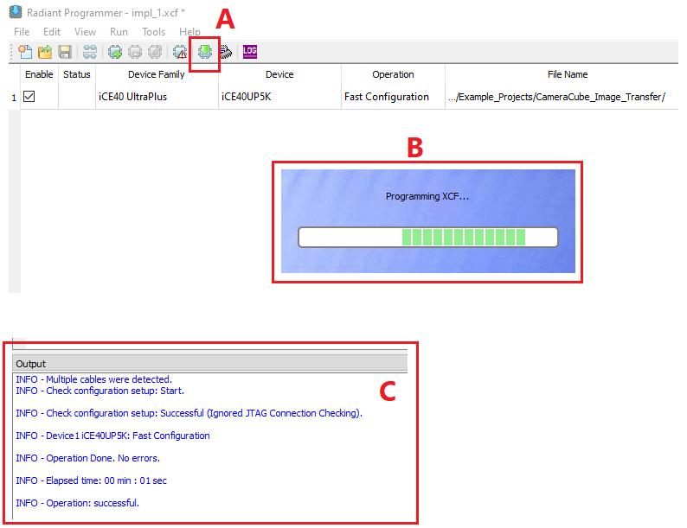

**Figure 4. Programming of FPGA**

1. After the programming of the FPGA finished successfully:
2. The "Config Done" LED is flashing steadily.
3. The CameraCube image sensor OV7690 is configuring.
4. The "Heart Beat" LED is flashing with the pulsing.
5. The image data from the Image Sensor “Camera Cube” appears on the pins of “Dbg/Prg Connector”:

o_image_data_gate pin 4

o_image_data_enb pin 5

o_image_data(0) pin 9

o_image_data(1) pin 1

o_image_data(2) pin 8

o_image_data(3) pin 2

o_image_data(4) pin 6

o_image_data(5) pin 3

o_image_data(6) pin 7

o_image_data(7) pin 10

# Revision History

|  |  |  |
| --- | --- | --- |
| Date | Version | Revision |
| 3/14/2021 | 0 | Original revision |
|  |  |  |
|  |  |  |